How to Build a Campfire for Cooking

The object is to have all the wood turn into coals at the same time. This gives an even fire with no flames reaching up to burn your food or blacken your cookware. It also yields the longest cooking time from the coals.  Prepare the site  - Select a fire site at least 8' from bushes or any combustibles. Be sure no tree branches overhang the site.  - Make a U-shaped perimeter using large rocks or green logs. If using logs, they'll need to be wet down from time to time. If breezy, have back of firepit face the wind.  - Put a large flat rock at the rear of the firepit to act as a chimney. The "chimney rock" will help direct the smoke up and away. |  | 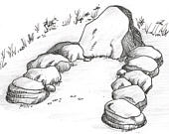
Lay the kindling  - Fill the fire area with crumpled paper or tinder.  - Lay kindling over paper in layers, alternating direction with each layer. Use thin splits of wood or small dead branches. Do not put kindling down "teepee style". The whole fire area should be covered with the kindling stack.  - Set a bucket of water near the fire area. Light the paper to start your fire. |  | 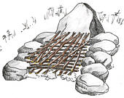
Build the fire, grade the coals  - When kindling is ablaze, add firewood. The wood should be all the same size, as much as possible. Use hardwood or hardwood branches if available. Distribute wood evenly over fire bed.  - As soon as the last flames die down leaving mostly white coals, use a stick to push the coals into a higher level at the back end and lower level at the front. This will give you the equivalent of 'Hi', 'Med' and 'Lo' cook settings. Or, level the coals to your preference. |  | 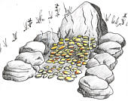
To cook, set the grill on rocks or wetted green logs. Put food directly on grill or in cookware and prepare your meal. If cooking directly on the grill, a small spray bottle or squirt gun is handy for shooting down any rogue flames, usually caused by food drippings.  As the fire diminishes, bank the coals to get the most heat from them.  After cooking, add wood for your evening campfire. Before retiring, extinguish thoroughly and soak with water. Turn rocks in on fire bed. It will be easy to reassemble the next day if required. |  | 